BSC – HGP - Assignment 1

Stock Trade Profit Calculator app

UI Design Document

Student Name: Stanislav Kril
Student Number: 3133810

1. Introduction
The Stock Trade Profit Calculator app is a graphical user interface application made to calculate profit based on historical stock market data retrieved from dataset. The app allows users to select a stock, quantity, purchase date with the sell date and calculate the total purchase cost. It displays then purchase cost, selling price, and profit.

2. Calculator Components

2.1 Stock Selection
The app displays a list of available stocks in a drop-down menu. The user can select their stock from this list.
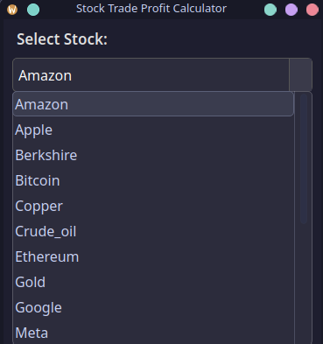

2.2 Quantity Input
The app provide a quantity input field where the user can specify the number of stock shares they have.
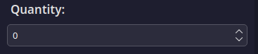

2.3 Purchase Date Selection
The app features a calendar widget for selecting the purchase date.
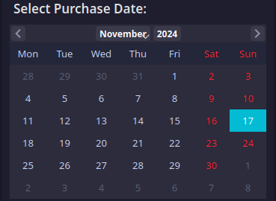

2.4 Sell Date Selection
The app also includes a calendar widget for selecting the sell date right after the purchase date calendar.
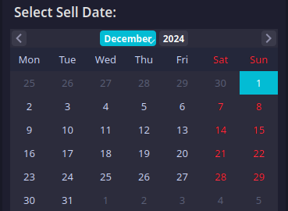

2.5 Calculation Results
The app displays the calculation results in the bottom of the calculator, including purchase total, sell total, and profit fields that displays results.
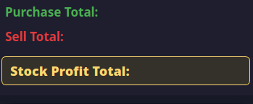
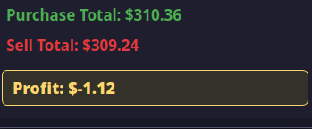

3.0 Components description

Control/Input Type:
- Drop-down menu: A drop-down list has been used to select stock. It has a convenient, easy to use interface, which allow users to select the available stocks quickly out of a predefined list. The list is automatically sorted in alphabetical order making it easy and fast to navigate and not having to manually type in with an easy to read font.
- Input field: The quantity field where a user can type the amount of stock units to buy are limited to non-negative integer numbers, eliminating the possibility of entering invalid numbers. This checks make sure that the quantity input is correct and data wont cause any calculation errors.

- Calendar widgets: Two calendar widgets represent the purchase date and the sell date. They implement graphical way of selecting dates instead of typing dates manually. The sell calendar is limited for selection a date that goes after purchase date and the purchase calendar cannot go beyond sell date. The two calendars have logical default dates, purchase date set to recent data date and sell date set to two weeks prior. Both of calendars formatted to include only month and year.

Location:
- Drop-down menu: The stock selection menu is located on the top of the window, and it is structured into the logical component. This is the first interactive element that the users will see when the calculator is opened, maintaining the top-down flow and corresponds to the usual patterns of UI design.

- Input field: The quantity field is placed just below the stock selection. This positioning are made for the user to easily navigate between selecting a stock and the required quantity.

- Calendar widgets: The two calendar widgets are placed below the quantity field in vertical order—first the purchase date, the second one is sell date. Following structure creates logical sequence improving usability with a clear and predictable flow of UI design.

Size:
- Font size: The interface based on font size of 16px, which is fitting good into the layout of calculator.

Style decisions:
- Color scheme: The calculator color schemes are chosen on a dark theme manner
  - The purchase total is displayed in green to indicate a cost.
  - The sell total is shown in red to representing a sell transaction.
  - The profit total is displayed in gold, making accent on gain.
- Font family: The basic font is "Segoe UI", Standard font with a clean appearance.

Additional Features:
- Error handling:
The application handles invalid input and data issues. It detects following errors:
  - A sell date set after a purchase date.
  - A quantity is zero or negative.
  - The selected stock or date lacks data in the dataset.
Each of following errors are displayed in the interface, with clear messages.
- Data validation:
The calculator also validate all user inputs to be are valid before performing calculations. It verifies:
  - Selected stock exists in the dataset.
  - Selected dates have stock prices in dataset.
  - Numeric inputs are in acceptable ranges.

